
lab setup
Cybersecurity & Ethical Hacking
APSPL2628505

Apex Planet


Project Writing Format- To be Implemented

Objective
- The objective of this mini-project is to create a virtual cybersecurity lab environment for practicing penetration testing and security analysis. This involves installing virtualization software and setting up two virtual machines: one acting as the attacker (Kali Linux) and the other as the vulnerable target (Metasploitable2) on an isolated network.

Tools & Environment
- The tools or software used.
Kali Linux
- The environment/setup
VirtualBox Lab with isolated test network.

Procedure / Steps
- The detailed steps taken to perform the task.

1. Install VirtualBox

Step 1 : Open your browser and go to the official website :

https://www.virtualbox.org

Step 2 : Click Download VirtualBox.

Step 3 : Download Windows hosts version.

Step 4 : Open the downloaded file and install it.

During installation click : Next → Next → Install → Finish

2. Download Kali Linux and Metasploitable Virtual Machine

Step 1 : Open the Kali Linux download page:
https://www.kali.org/get-kali/
https://sourceforge.net/projects/metasploitable/
Step 2 : Scroll to Virtual Machines.
  - Download : Kali Linux VirtualBox Image
  - File example : kali-linux-2025.x-virtualbox-amd64.7z
  - Size : 4–5 GB

  - Extract the Metasploitable2 file.
  - Open VirtualBox.
  - Click Add or Import Appliance.
  - Select the Metasploitable2 virtual machine file.
  - Start the machine.
3. Extract Kali Linux and Metasploit File
The downloaded file is compressed.

4. Import Kali Linux into VirtualBox

Step 1 :Open VirtualBox.
Step 2 : Click : Machine → Add
Step 3 : Select the file : Kali-Linux.vbox
Now Kali Linux will appear in the VirtualBox machine list.

5. Adjust Virtual Machine Settings
Before starting, increase system resources.
Step 1 : Right click Kali Linux → Settings System → Processor
Step 2 : Set: 2 CPUs
Step 3 : System → Memory
Minimum : 4096 MB (4 GB)
8192 MB (8 GB)
Step 4 : Display → Video Memory
Step 5 : Set : 128 MB

- Open VirtualBox Network Settings.
- Set Metasploitable2 network adapters to:
  - Host-Only Adapter or Internal Network
- This allows communication between the two machines but isolates them from the internet.

Step 6: Start Both Virtual Machines
- Start the Metasploitable2 machine.
- Start the Kali Linux machine.

Step 7 : Login to Kali Linux
Default login credentials:

Username: kali
Password: kali

Proof / Screenshots
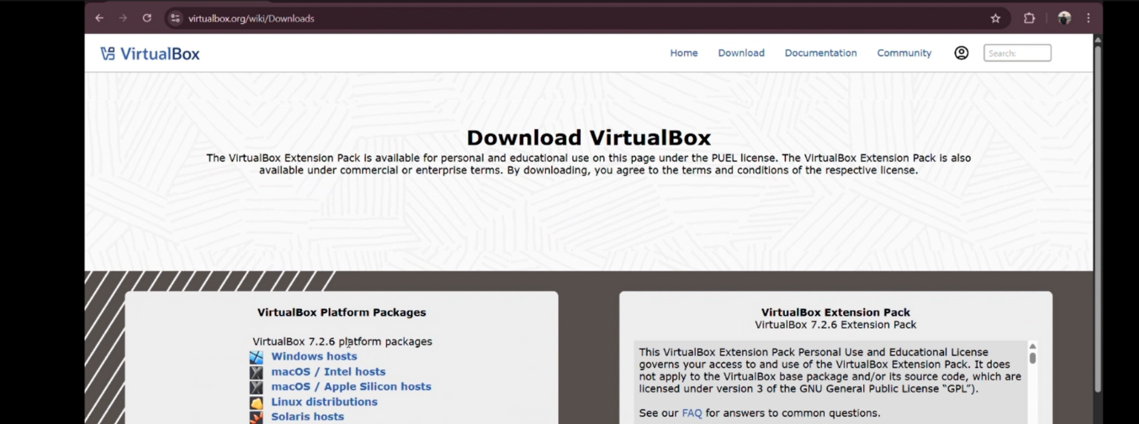
- The evidence of task completion.

Fig 1.1 virtualbox.com

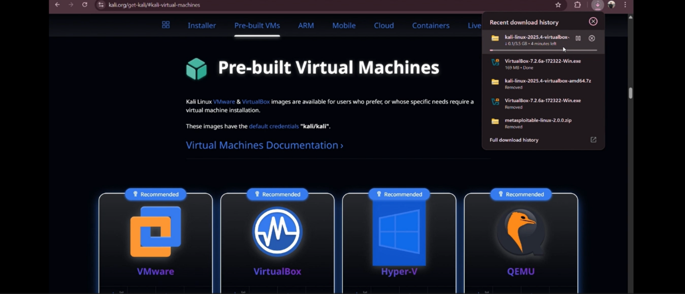
Fig 1.2 Virtual Machines
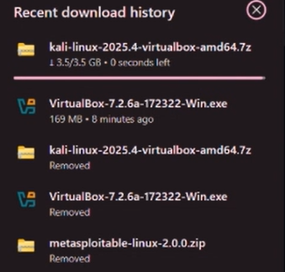

Fig 1.4 Downloads

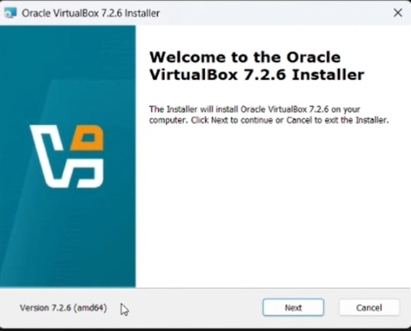

Fig 1.4 Installer

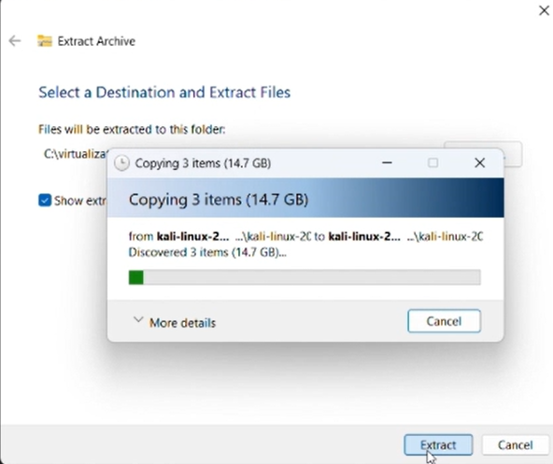

Fig 1.5 Extraction
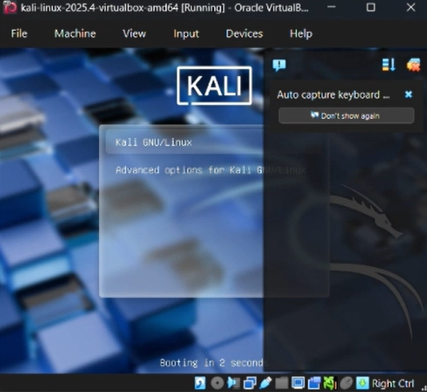

Fig 1.6 Kali Linux
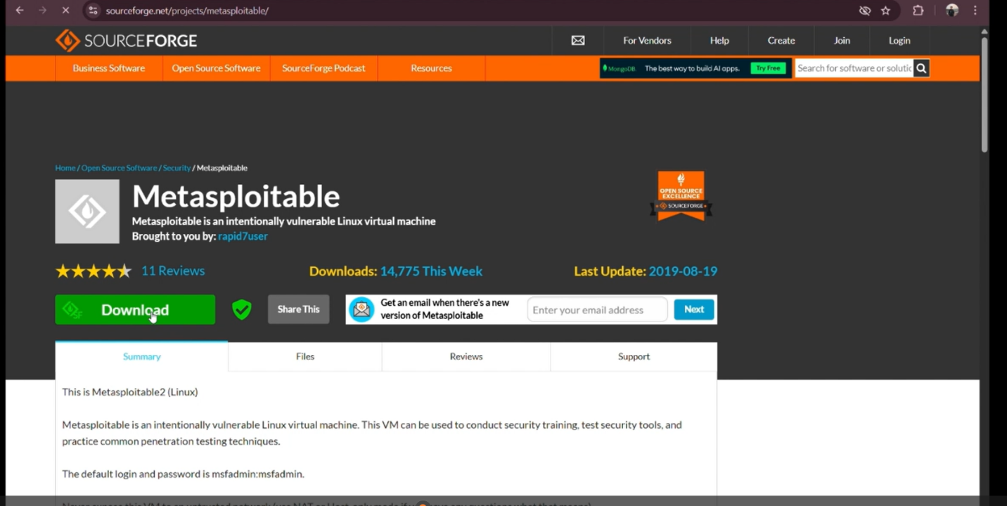

Fig 1.7 Metasploitable
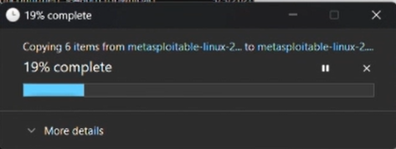

Fig 1.8 Downloading
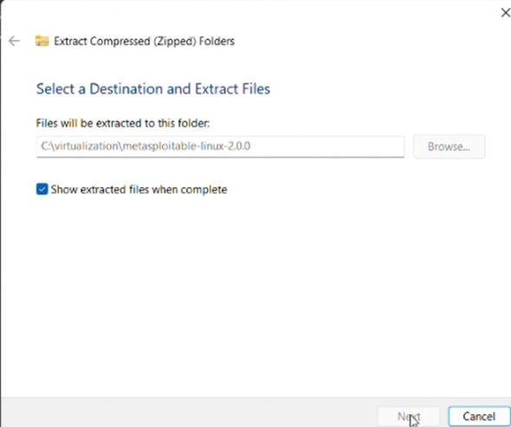
Fig 1.9 Extraction of File

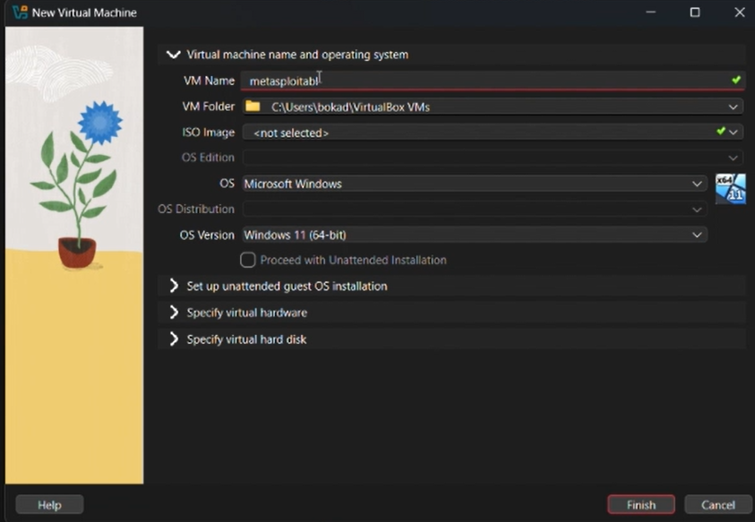

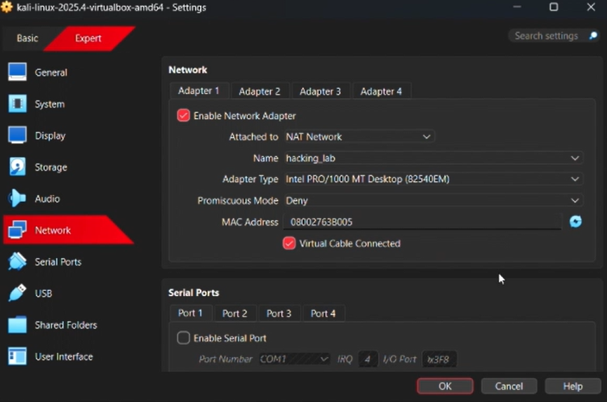
Fig 1.10 Create a new virtual machine

Fig 1.11 Network Settings
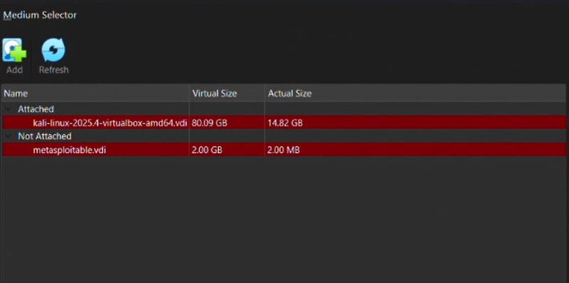

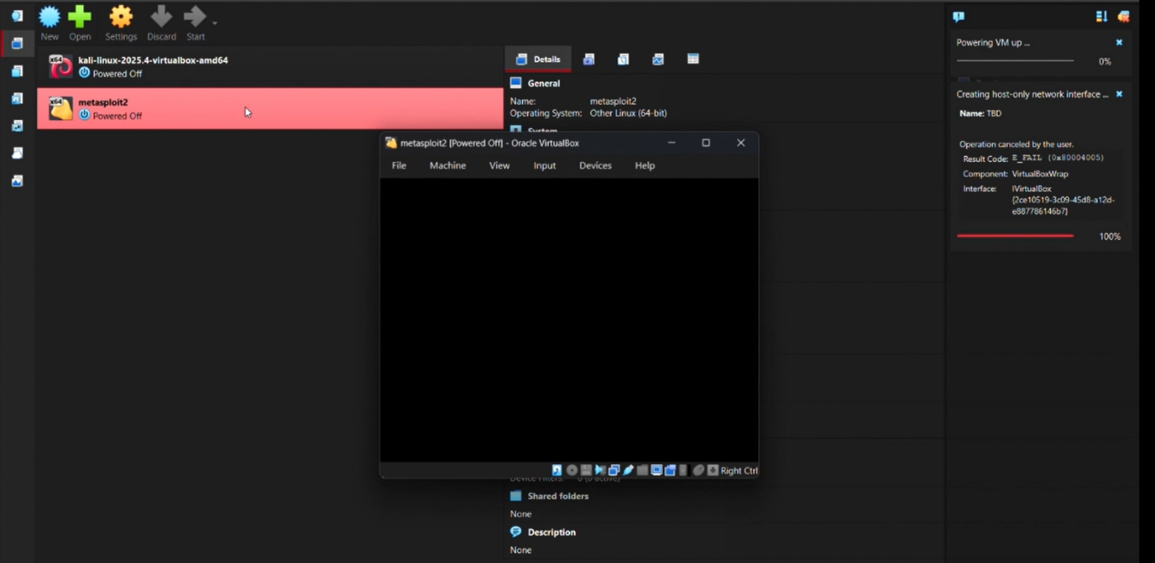
Fig 1.12 more setting

Fig 1.13 New Machine Created

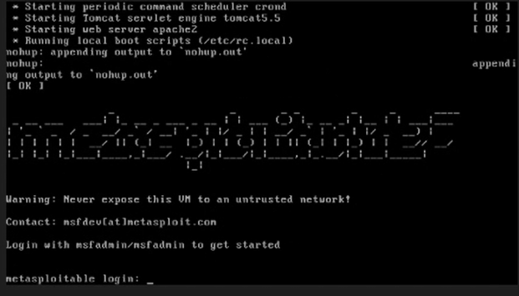
Fig 1.14 Metasploitable

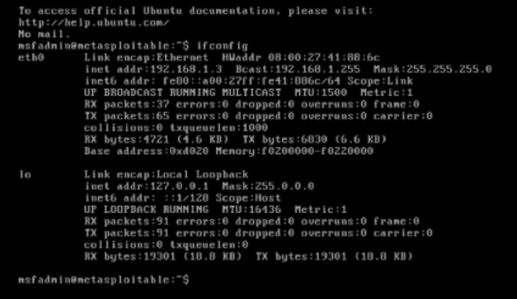
Fig 1.15 msfadmin

Analysis / Interpretation
- The virtual lab environment allows safe testing of cybersecurity tools and penetration testing techniques. By isolating the network, attacks performed from Kali Linux will only affect the Metasploitable2 machine and not the real network. This setup is widely used for learning ethical hacking and vulnerability analysis.

Mitigation / Recommendations
- Always keep the lab isolated from the main network to avoid accidental attacks on real systems.
- Allocate sufficient RAM and CPU resources to ensure smooth operation of virtual machines.
- Regularly update Kali Linux tools to use the latest security testing utilities.
- Use snapshots in VirtualBox to restore the system if the environment becomes unstable.
Conclusion
- This project successfully created a virtual cybersecurity lab using Kali Linux and Metasploitable2. The isolated environment allows safe experimentation with penetration testing tools and techniques, providing a strong foundation for learning ethical hacking and network security.

